**sudo mysql_secure_installation**



Press **<Enter>**.



Now, press **Y** and then press **<Enter>**.



Now, type in your **root** password and press **<Enter>**.



Type in your **root** password again and press **<Enter>**.

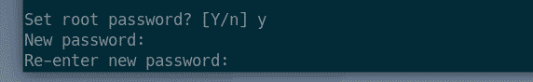

Press **Y** and then press **<Enter>** to remove anonymous users.

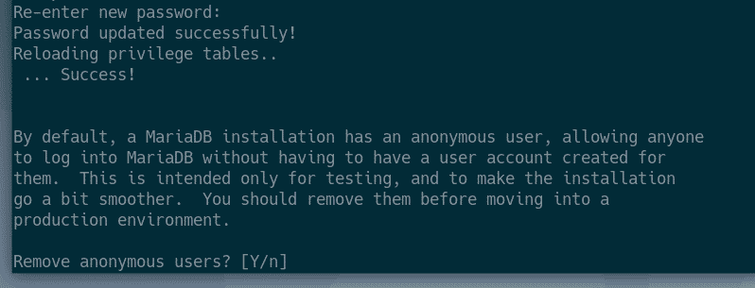

If you don’t want to allow **root** login remotely, press **Y**. Otherwise, press **N**. Then, press **<Enter>**.

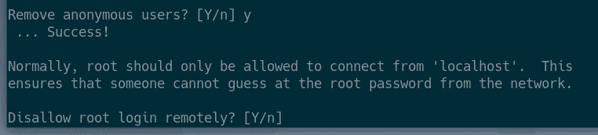

Now, press **Y**and press **<Enter>** to remove test database.

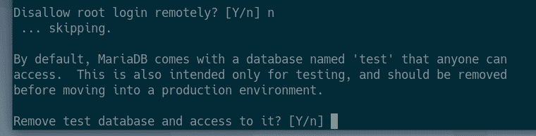

Now, press **Y** and then press **<Enter>** to reload the privilege table.

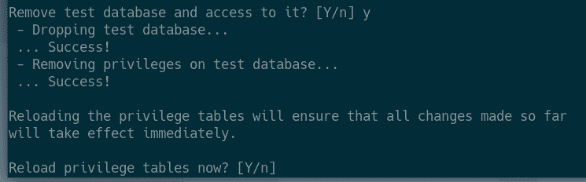

MariaDB should be configured.

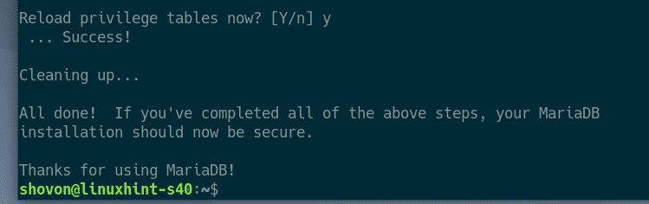

**Creating a New MySQL/MariaDB User for phpMyAdmin:**

You can’t login to the latest version of MySQL/MariaDB database as **root** user without super user privileges. So, you can to create a non-root MySQL/MariaDB user and grant it required permissions to be able to use it from phpMyAdmin. It’s pretty easy to create a new user in MySQL/MariaDB.

First, login to MariDB shell with the following command:

*$-***sudo mysql -u root -p**



Now, type in the MariaDB **root** password you’ve already set and press **<Enter>**.



You should be logged in.

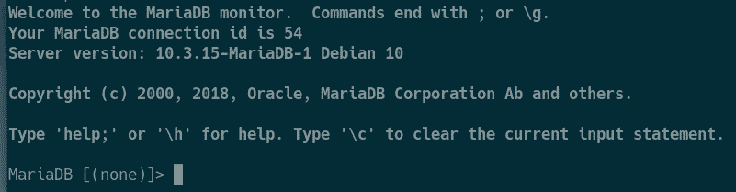

Now, create a new user **shovon** (let’s say), set the password **123** for the user and grant all the privileges to the user with the following SQL statement:

[**GRANT**](https://search.oracle.com/search/search?group=MySQL&q=GRANT)[**ALL**](https://search.oracle.com/search/search?group=MySQL&q=ALL)[**ON**](https://search.oracle.com/search/search?group=MySQL&q=ON)**\*.\***[**TO**](https://search.oracle.com/search/search?group=MySQL&q=TO)**'tony'@'localhost' IDENTIFIED BY 'rootroot';**

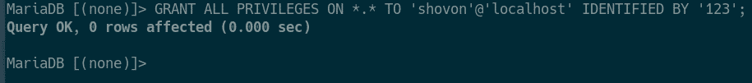

For the changes to take effect, run the following SQL statement:

**FLUSH PRIVILEGES;**

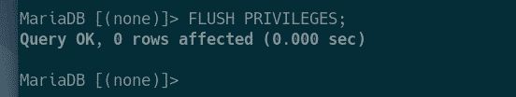

Now, exit out of the MariaDB shell as follows:

\q